

HOLMBUSH PRIMARY ACADEMY
Hawkins Crescent
Shoreham-by-Sea
West Sussex
BN43 6TN
Telephone 01273-592471
Tel/Fax 01273-592660

Email office@holmbushprimaryacademy.org.uk
www.holmbushprimaryacademy.org.uk

Head of Learning: Ms Rebecca Jackson BEd Hons, MA Ed, NPQH

June 2015

Dear Parents/Carers

Supporting everyone in our school community

The governing body was dismayed to learn at a recent governing body meeting that there have been 37 incidents of abuse against members of staff by parents. As an employer we take our duty of care for the staff extremely seriously and no one should be at the receiving end of abuse in the place they work.

We also understand that parents can be upset, frustrated or cross about school procedures or decisions that they don’t agree with but these should be dealt with in a respectful way to all involved. Our core school value is respect and we are all responsible for modelling that to our children.

The following is to clarify for parents how to deal effectively with any issues or complaints to get them resolved:

In the first instance always speak to your child’s class teacher.
If within 24 hours you feel the matter is still not resolved satisfactorily arrange to see a senior member of staff: Mrs McKechnie, Mrs Pilbrow or Miss Stickley.
If following this meeting and after 48 hours you still feel the matter is not resolved arrange to see Ms Jackson.
All appointments with staff can be made through the office or on the online contact form at our website.

Having gone through this process, if you feel your issue has not been dealt with or it is still on-going or you are not happy with the way it has been dealt with, you can make a formal complaint to the governing body by writing to them, addressing it to the clerk of governors. (Please see the Trust Complaints Policy which is on the website under the ‘For Info’ bar).

Parents who speak to Ofsted, the Local Authority or their local MP will be asked if they have followed this procedure and may find that their complaint does not reach the school or is not addressed via these channels. So it is always best to approach someone in school or a governor.

The governing body will not tolerate abuse against members of staff and will not hesitate to report serious incidents to the Police.

The following is the advice that has been given to staff when dealing with an abusive situation. All incidents will now be logged.

Threatening and abusive phone calls/emails/letters
If a member of staff is sworn at, shouted at, threatened or abused over the phone they will end the call immediately. Abusive, threatening or rude correspondence will be passed straight to a member of the governing body and may be reported to the Police under the Malicious Communications Act. Emails and letters of this nature will not be responded to and will be kept on file.

Threats and abuse face to face
If a member of staff is shouted at, sworn at or abused in a face to face situation or during a meeting that meeting will be ended immediately and staff will walk away to find another member of staff. This incident will then be logged and any further communication needed will need to be arranged through the office with a senior member of staff present.

Physical violence is not tolerated and the Police will be phoned immediately.

Social Media
Threatening and abusive communication via social media is dealt with by our legal team and is always reported.

The consequences of these actions may result in a letter from our legal service, a site ban or legal action. In the past some parents have been banned from the site or received a PIN - Public Information Notice.

Police Information Notices (PINs) are issued by the police where there are allegations of harassment. These notices are sometimes called Harassment Warning Notices.

The Malicious Communications Act 1988 (MCA) is a British Act of Parliament that makes it illegal in England and Wales to "send or deliver letters or other articles for the purpose of causing distress or anxiety". It also applies to electronic communications and social media interactions.

Yours faithfully

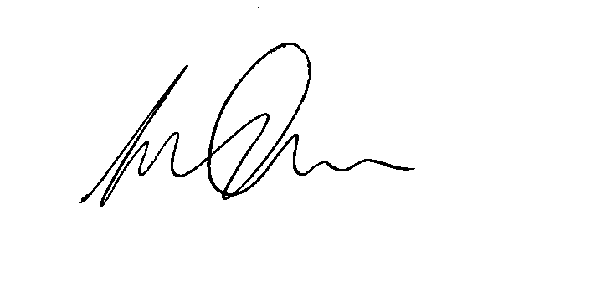

On behalf of The Governing Body

